## **Candle Lab (Student Guide)**

In this investigation, you will make some qualitative observations of a chemical reaction. During a chemical reaction, one or more substances change into one or more other substances. The burning of wood, wax, oil, gasoline, and coal are examples of a chemical reaction known as combustion. The reaction you will study in this investigation is a combustion reaction.

**Purpose**

To observe and interpret a chemical reaction using qualitative observations.

**Equipment**

Glass slide (can be replaced with a small, flat plate)

Candle/ Tea candle

Matches (or barbeque lighter)

Scoopula (can be replaced with a knife)

Metric ruler

Aluminum foil

Tongs

String (ideally similar diameter as the wick of your candle)

Toothpick

**Safety**

In this experiment you will be working with an open flame. Tie back long hair, do not wear loose fitting clothing, and wear eye protection. Be sure to conduct the experiment on a clear, flat, hard surface (ideally ceramic or metal). Ensure that all matches and burned materials are completely extinguished (consider placing these in a container with water) before they are discarded. You should also be mindful of the liquid wax. It is hot and it is possible to receive burns from this.

**Procedure**

*Record observations for each step.*

1. Note appearance, odour and feel of the unlit candle.

2. Light the candle and allow it to burn for several minutes. Note any changes. Briefly describe the burning candle.

3. Blow out the flame and immediately place a lit match in the “smoke” about 2 cm above the wick. As show image[1] below:

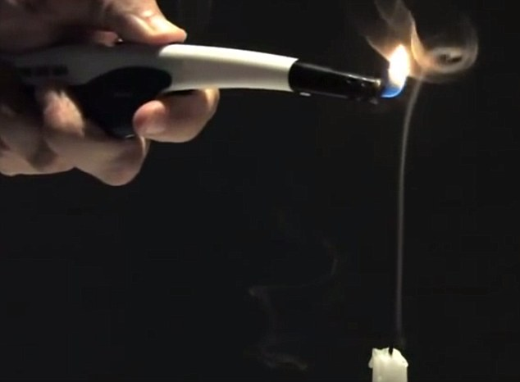

4. Using a scoopula to transfer a small amount of liquid from the bowl of the candle onto a slide. Try to light it and note the result.

5. Place a toothpick into the soft candle next to the unlit wick to form a wooden wick. Light the toothpick and note the result.

6. Place a length of string about 4 cm long on the glass square. Light it and observe its behavior.

7. Make a slit in a small piece of aluminum foil. Light the candle. Carefully, place the foil between the base of the flame and the liquid in the candle bowl. Note the behaviour of the flame. See image below:

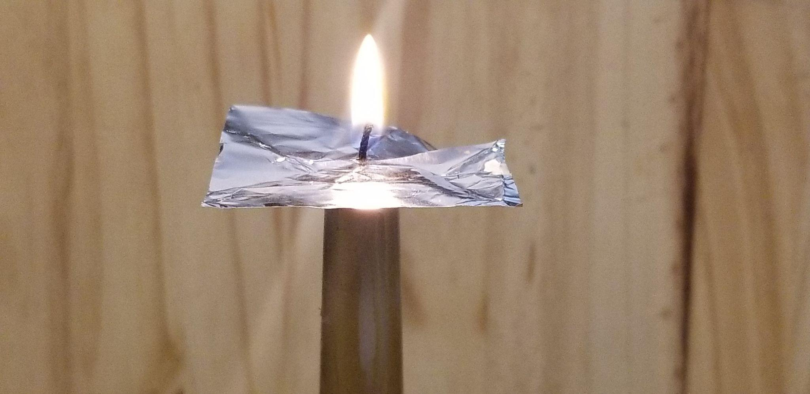

**Conclusions and Questions**

1. What phases (solid, liquid, gas) are present in the unlit candle? What phases (solid, liquid, gas) are present in the burning candle? Which phase appears to take part in the chemical reaction? Defend your response with evidence from your observations.

2. What part does the wick play in the burning of the candle? What properties should the wick have? Explain the result when aluminum is placed between the liquid and the wick. Is the wick part of the chemical reaction? Defend your response with evidence from your observations.

3. A source of energy is needed to start the burning of the candle. What energy source is used? Is the overall reaction exothermic or endothermic?

4. Give an example in this lab that illustrates the difference between observation and interpretation.

1. Dailymail.com, James Gordon For. “Smoke from an Extinguished Flame Can Relight a Candle’s Fire.” *Daily Mail Online*, 17 May 2015, www.dailymail.co.uk/news/article-3084929/Relight-fire-smoke-extinguished-flame-used-bring-candle-life.html.