## **Hooke’s Law Lab (Student Guide)**

**Who is Robert Hooke?**

In 1678 English Physicist Robert Hooke published a study about how "the extension is proportional to the force". He established that most solids behave (at times) with elastic properties; even very "inelastic" materials like steel will behave elastically under large loads. In short, he proved the relationship between:

* “F” which is a "spring force" or "restoring force" as the spring tries to return to its original or unloaded form (Units: N)
* “k” which is the "constant of elasticity" or basically a number that describes how elastic or stretchy a material is (Units: N/m)
* “Δx” which is the elongation or the deformation of the spring. Basically, the difference in length of the spring when stretched from its unstretched length. (Units: m)

**Purpose**

To determine the spring constant (k) of a material using Hooke’s law.

**Procedure and Observations**

1. Go to:[PhET: Masses and Springs](https://phet.colorado.edu/sims/html/masses-and-springs/latest/masses-and-springs_all.html)
2. Click on “Lab”.
3. Click on the red **minus** square of the Energy Graph to close it (not needed for this Lab).
4. Check the boxes on the right hand side (**Displacement-Natural length, Mass equilibrium and the Movable Line**).
5. Keep the **Gravity** to **Earth**.
6. Keep the **Damping** slider to “**none**” in order to mimic a frictionless situation.
7. Grab and slide the **ruler** so its zero point rests at the Natural length line (the blue dashed line) to measure the extension of the spring.
8. Move the **Spring Constant** slider about halfway between Small and Large.
9. Grab and attach the **mass** to the spring. You may vary its value using the slider on the left of the spring.
10. You may change the speed of the motion by selecting **Slow** instead of **Normal** and you can **Pause** or **Single forward** the motion if you want.

This is what your set-up should look like before you attach the mass onto the spring.

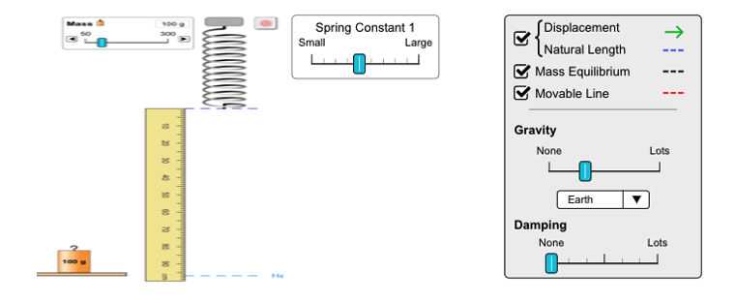

Images are not to scale.

**Procedure**

Develop a procedure and write each step needed for the calculation of the constant.

|  |  |
| --- | --- |
| **Step 1** | Set the slider of the Spring Constant somewhere between Small and Large and do not change it. |
| **Step 2** |  |
| **Step 3** |  |
| **Step 4** |  |
| **Step 5** |  |
| **Step 6** |  |
| **Step 7** |  |

**\*You may not need all boxes or you may need more.**

Apply the procedure you developed to collect data needed to find the spring constant.

**Data Table**

|  |  |  |  |  |
| --- | --- | --- | --- | --- |
| **Mass (g)** | **Mass (kg)** | **Weight (Fg) (N)** | **Extension**  **(cm)** | **Extension  (m)** |
|  |  |  |  |  |
|  |  |  |  |  |
|  |  |  |  |  |
|  |  |  |  |  |
|  |  |  |  |  |
|  |  |  |  |  |

**Graphing results:**

Force (N) as a function of extension (m): Calculation of slope:



**Analysis**

What is the significance of the slope of the graph you drew?

|  |
| --- |
|  |
|  |
|  |
|  |
|  |

Prove Hooke’s mathematical relationship as mentioned above using the data collected.

|  |
| --- |
|  |

**Conclusions**

Describe the link between the value of “k” and its stretching ability.

|  |
| --- |
|  |
|  |
|  |
|  |
|  |