## **Hooke’s Law lab (Teacher Guide)**

### 

### **Purpose**

To determine the spring constant (k) using Hooke’s law as well as interpreting the spring constant when comparing the “k” of two or more springs.

### **When To Do This Investigation**

This activity is designed to have students grasp the concept that if a spring is stretched or compressed, it tends to return to its initial shape once the applied force has been removed. This elastic range of stretchable material can be demonstrated using a simple rubber band.

The idea that students must understand prior to this experiment is that when a measurable force is applied to a spring (or any material that is elastic), we can either find the change in length and/or the spring constant “k” when the other value is given. In other words, this experiment will work best if the students have already understand the mathematical relationship of Hooke’s law:

$k=\frac{F}{Δx}$ OR $Δx=\frac{F}{k}$

### **Materials**

This investigation is done using a free virtual simulation on the **Intro** option of the PhET simulation called [PhET: Masses and Springs](https://phet.colorado.edu/sims/html/masses-and-springs/latest/masses-and-springs_all.html) (produced by the University of Colorado Boulder). No hands-on materials are required other than a scientific calculator.

* **OPTION for a hands-on, at-home experiment**:

As part of the prior knowledge, students must have covered the Force due to gravity (Fg =mg) as ultimately, it is the one force applied to the rubber band when trying to find its constant of elasticity. Also, reminding students that the density of water is 1g/mL will be needed to find the mass added to the rubber band.

Students could use:

* Different size rubber bands or a couple of the same that can be doubled up
* 500 mL empty water bottle
* A piece of metal wire to make a hook (twist tie or opened up paper clip)
* A measuring stick or tape measure
* Measuring cups and spoons
* Water
* Use of a door handle or cupboard door handle
* Calculator
* Graph paper

A similar set-up as the one in the picture could be appropriate. Students should be able to collect several changes in length with increasing volumes of water. If any students do not have access to a scale, then they could approximate the applied mass using the volume and density (at STP) of water. The extension of the elastic when the empty water bottle is attached would then be used as the “natural length” of the elastic and $Δx$ would be calculated/ measured using this reference.

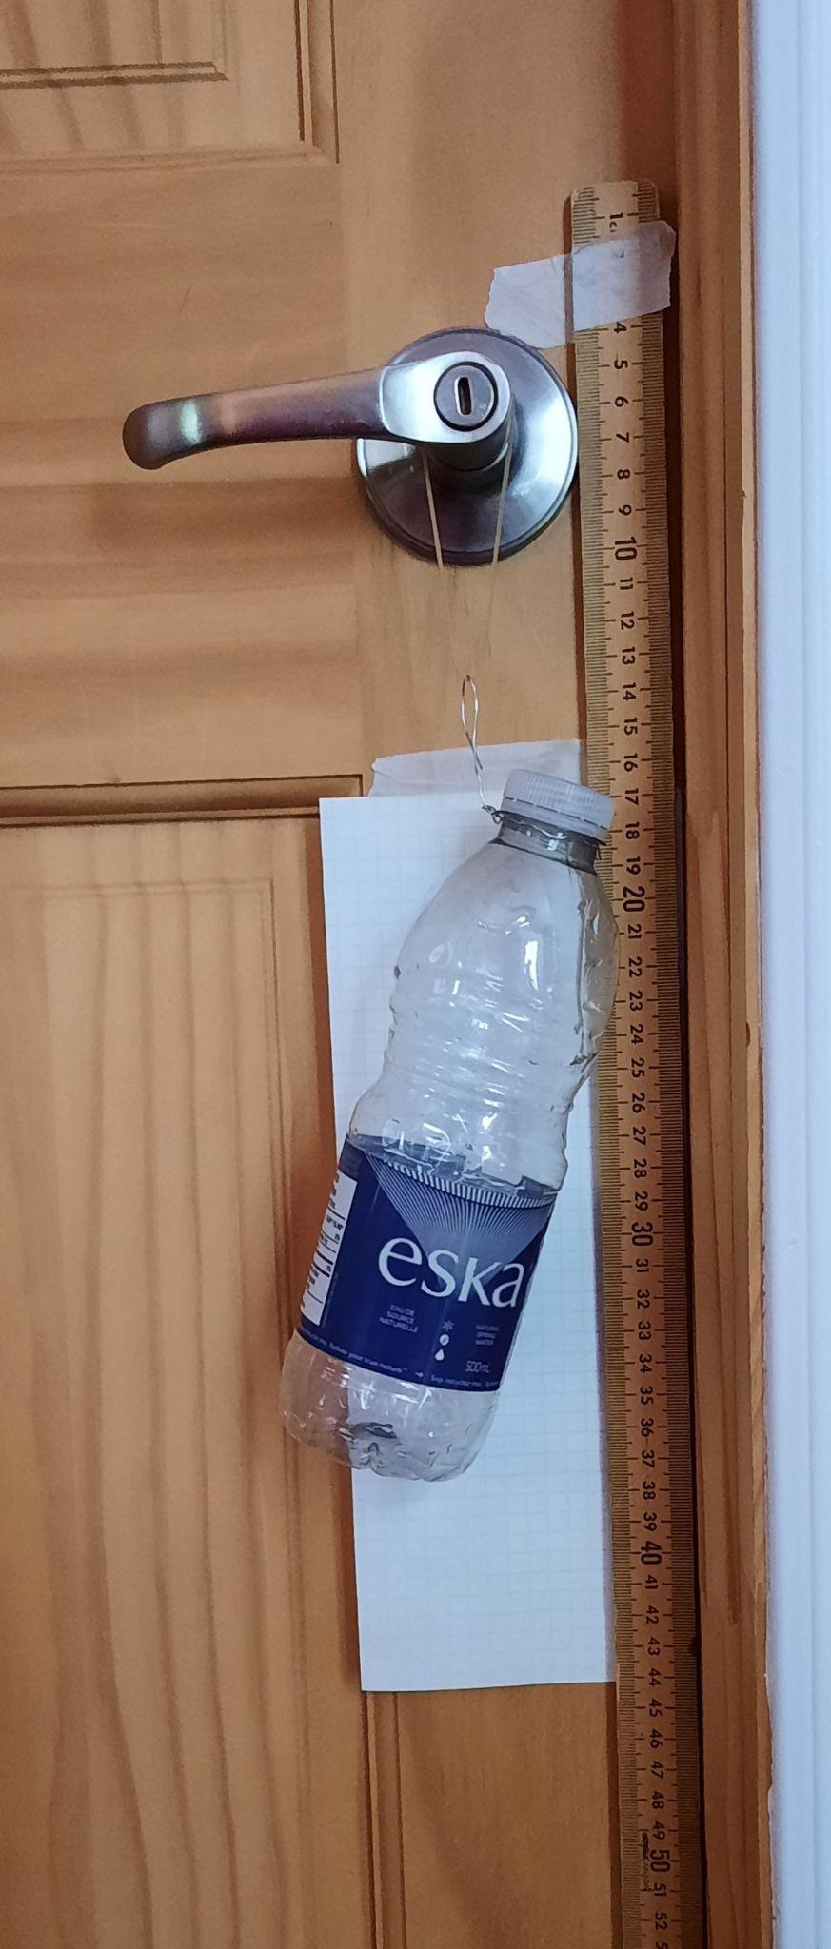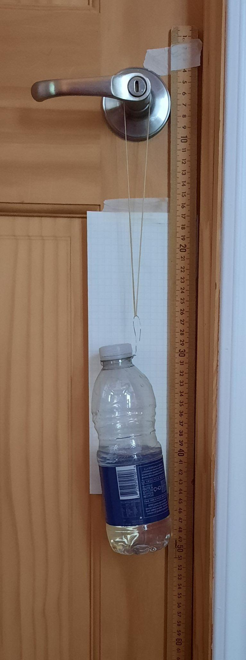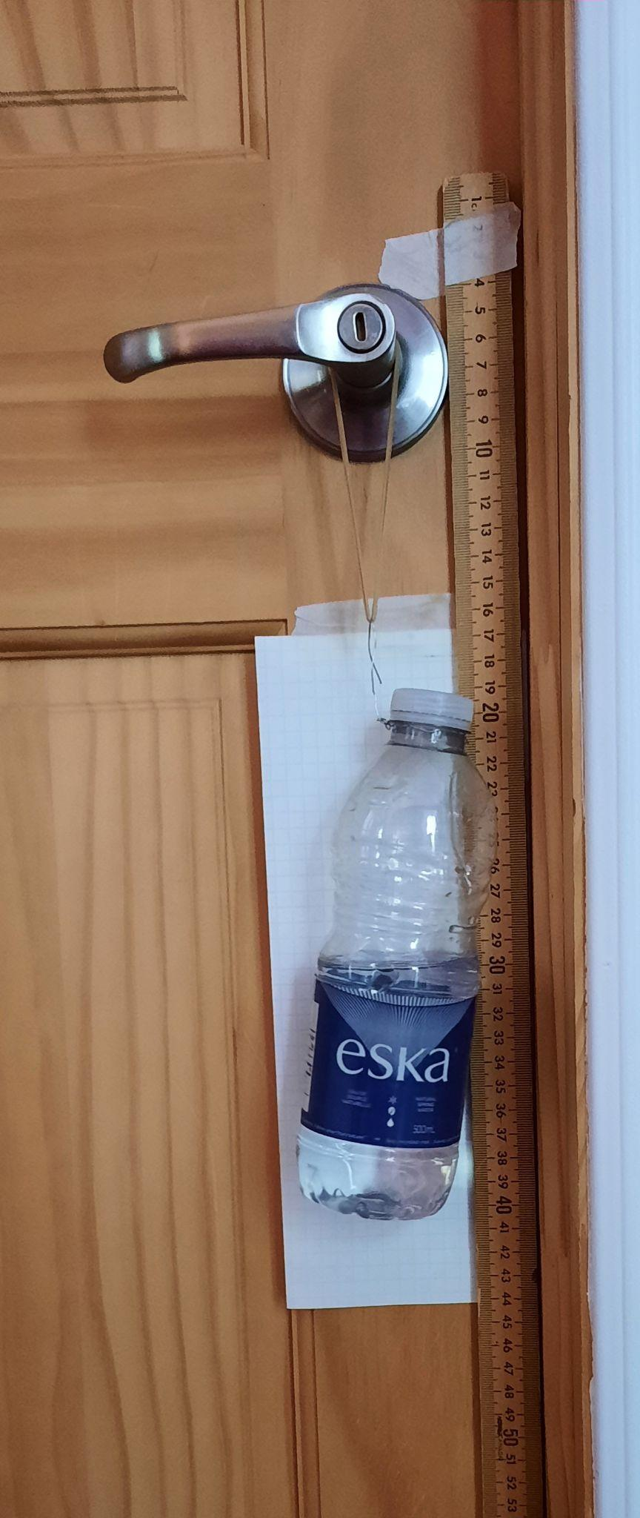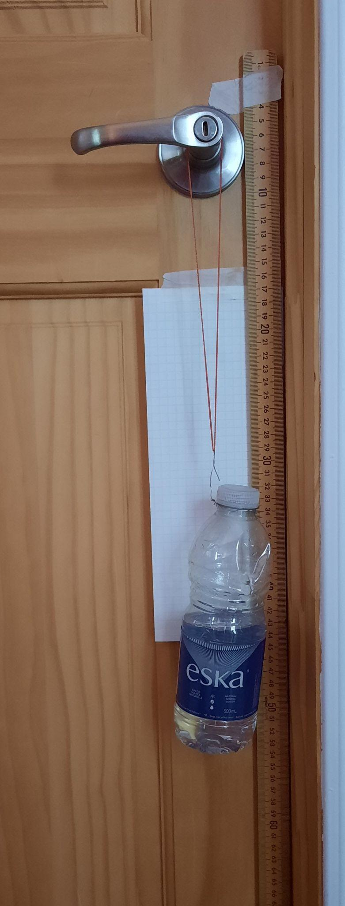

No water 1 rubber band 2 rubber bands Other rubber band

**Take note that when graphing the force as a function of length, it is possible that there will only be a portion of the graph that will truly be linear. Using a line of best fit could be necessary.

### **Results & Sources of Error**

This is an investigation where the data collected from the simulation is consistent; therefore, all of the students' data tables and graphs would be identical. It is recommended that the focus be on interpreting and analyzing the data, but the teacher could give each student different independent variable values to collect data for.

Be aware that using the at-home option could bring several sources of error such as misreading the change in length of the rubber band, measuring water quantity without being consistent, etc.

### **Safety Considerations**

There are no safety considerations for this investigation since it is purely virtual.

When doing the at-home option, be prepared for a water spill. Also discuss ways to find a suitable range of “mass” to add that will avoid breaking the elastic. The mass (bottle) should also be lowered into equilibrium (and not dropped).

### **Evaluation**

There is a provided rubric for this investigation that teachers can use or modify as needed. Note that the spreadsheet has two tabs, including one with instructions for the teacher on how it works.

**Physics – Hooke’s Law Investigation**

**(ANSWER KEY for Student Guide)**

**Procedure**

Develop a procedure and write each step needed for the calculation of the constant.

|  |  |
| --- | --- |
| **Step 1** | Set the slider of the Spring Constant somewhere between Small and Large and do not change it. Answers will vary. |
| **Step 2** | Select a value for the mass. |
| **Step 3** | Attach the mass to the spring. |
| **Step 4** | Use slow motion to find the length with the ruler tool |
| **Step 5** | Calculate Fg = mg |
| **Step 6** | Graph data collected. |
| **Step 7** | Find slope of graph |

**\*You may not need all boxes or you may need more.**

Apply the procedure you developed to collect data needed to find the Spring constant.

**Data Table:** Answers will vary depending on the choice of parameters.

|  |  |  |  |  |
| --- | --- | --- | --- | --- |
| **Mass (g)** | **Mass (kg)** | **Weight (Fg) (N)** | **Extension**  **(cm)** | **Extension  (m)** |
|  |  |  |  |  |
|  |  |  |  |  |
|  |  |  |  |  |
|  |  |  |  |  |
|  |  |  |  |  |
|  |  |  |  |  |

**Graphing results:**

Force (N) as a function of extension (m): Calculation of slope:



**Analysis**

What is the significance of the slope of the graph you drew?

|  |
| --- |
| It represents the value of the Spring constant k for this spring. |
|  |
|  |

Prove Hooke’s mathematical relationship as mentioned above using the data collected.

|  |
| --- |
| Students should come to the conclusion that the slope of Force as a function of change in length is Hooke’s law. $$k=\frac{F}{Δx}$$ |

**Conclusions**

Describe the link between the value of “k” and its stretching ability.

|  |
| --- |
| If k increases, F will need to increase to have identical Δx |
| If k increases, Δx will decrease for identical F |
| K and Δx are inversely proportional while F and k as well as F and Δx are proportional. |