## Solenoid Lab (Teacher Guide)

### 

### 

### Purpose

The purpose of this investigation is to get students to better understand two of the factors that affect the magnetic field strength of a solenoid; specifically, how **increasing the number of loops and/ or current** in a solenoid **increases the strength of the magnetic field** produced by the solenoid at a specific point in space.

### When To Do This Investigation?

This is designed to be completed after students have been introduced to the magnetic field around a current carrying wire. Although they should know what a solenoid is, it could be used to introduce the characteristics of a solenoid, or support their understanding of them. They also need to understand the relationship between voltage, current and resistance in order to make a hypothesis in Part II of the experiment.

If you feel like your students need some reminders about these concepts, here are some helpful resources to consider having them explore as a pre-lab activity:

# Magnetic Field around a Wire: <https://javalab.org/en/magnetic_field_around_a_wire_en/>

# Basic Electricity - What is voltage?: <https://youtu.be/TBt-kxYfync>

### Materials

This investigation is done using a free virtual simulation on the [PhET](https://phet.colorado.edu/) website (produced by the University of Colorado Boulder) and a virtual timer. No hands-on materials are required. The students will require access to a spreadsheet program or graph paper.

### Results & Sources of Error

This is an investigation where the data collected from the simulation is consistent (when the meter is placed in the same field location); therefore, it is possible for two students’ data tables and graphs to be identical. It is recommended that the focus be on interpreting and analyzing the data. The teacher can give each student different independent variable values to collect data for, or make sure that they have placed the meter in different field locations. This will yield different results and can easily be changed by individualizing the student guide. A screenshot showing the placement on the meter within the field could also be requested by the teacher prior to data collection.

Although it mentions which to focus on in the student guide, the simulation does have multiple measurements on the meter displaying the field strength and the students may be confused by the component measurements.

### Safety Considerations

There are no safety considerations for this investigation since it is purely virtual. For those classes that have done some hands-on electricity labs prior to the investigation, a good follow-up question could be to ask the students to consider what safety precautions they may need to consider if they were to do the experiment with physical materials.

### Evaluation

There is a provided rubric for this investigation that teachers can use or modify as needed. Note that there are two tabs in the spreadsheet, including one with instructions for the teacher on how it works.

## 

## Solenoid Lab (Possible ANSWER KEY for Student Guide)

**Part I**

**Hypothesis**

If the number of loops in the solenoid increases, then the strength of the magnetic field will … because…

Answers will vary, but the students should be able to make a link between a solenoid and the magnetic fields of a current carrying conductor. ie: if the number of loops in the solenoid increases, then the strength of the magnetic field will increase, because each loop acts like a current carrying wire, which will produce a magnetic field. The magnetic fields of each current carrying wire will augment.

**Observations**

|  |  |
| --- | --- |
| Number of loops | Field strength (G) |
| 1 | 0.38 |
| 2 | 0.76 |
| 3 | 1.14 |
| 4 | 1.52 |

**Analysis**

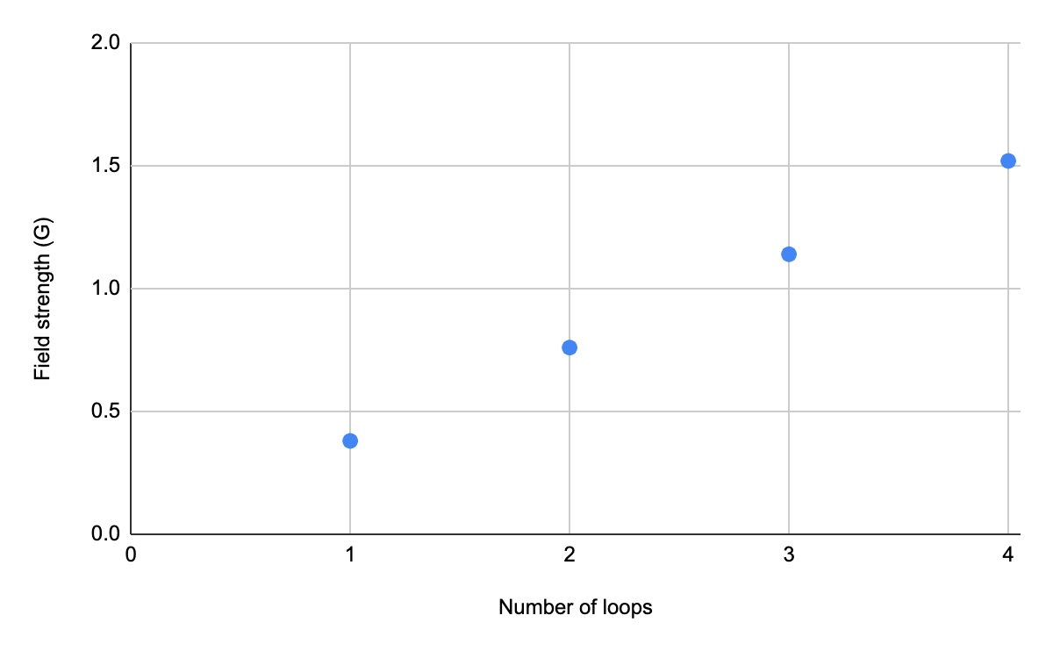

This does appear to be a proportional linear relationship (passes through the origin).

**Conclusion**

As the number of loops in a solenoid increases, so does the field strength at a given position around the solenoid. This does support my hypothesis.

**Part II**

**Hypothesis**

Answers will vary, but the students should be able to make a link between the field strength of a current carrying conductor and the rate of flow of charge (current).

**Observations**

|  |  |
| --- | --- |
| Voltage (V) | Field strength (G) |
| 1 | 0.15 |
| 2 | 0.30 |
| 3 | 0.46 |
| 4 | 0.61 |
| 5 | 0.76 |
| 6 | 0.91 |
| 7 | 1.06 |
| 8 | 1.21 |
| 9 | 1.37 |
| 10 | 1.52 |

**Analysis**

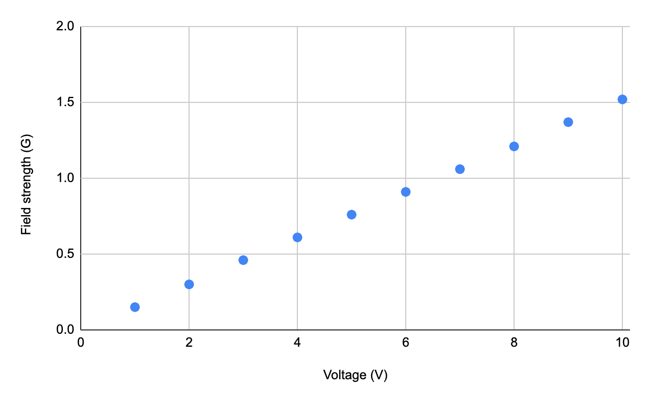

This does appear to be a proportional linear relationship (passes through the origin).

**Conclusion**

In general, what happens to the field strength of the solenoid as the voltage increases? Do these results support your hypothesis?

Answers will vary, but the student should make a connection between an increase in voltage and an increase in current. ie: as the voltage of the solenoid increases, so does the field strength at a given position around the solenoid. This does support my hypothesis because Ohm’s law shows that as volvate goes up across a set resistor so does current. This solenoid is a set length of wire (same # of loops) and should have the same resistance throughout the experiment. Therefore, an increase in voltage should also result in an increase in current.