Hooke’s Law Lab
(Student Guide)

Who is Robert Hooke?
In 1678 English Physicist Robert Hooke published a study about how "the extension is proportional to the force". He established that most solids behave (at times) with elastic properties; even very "inelastic" materials like steel will behave elastically under large loads. In short, he proved the relationship between:
- “F” which is a "spring force" or "restoring force" as the spring tries to return to its original or unloaded form (Units: N)
- “k” which is the "constant of elasticity" or basically a number that describes how elastic or stretchy a material is (Units: N/m)
- “Δx” which is the elongation or the deformation of the spring. Basically, the difference in length of the spring when stretched from its unstretched length. (Units: m)
Purpose
To determine the spring constant (k) of a material using Hooke’s law.

Procedure and Observations

- Go to: PhET: Masses and Springs
- Click on “Lab”.
- Click on the red minus square of the Energy Graph to close it (not needed for this Lab).
- Check the boxes on the right hand side (Displacement-Natural length, Mass equilibrium and the Movable Line).
- Keep the Gravity to Earth.
- Keep the Damping slider to “none” in order to mimic a frictionless situation.
- Grab and slide the ruler so its zero point rests at the Natural length line (the blue dashed line) to measure the extension of the spring.
- Move the Spring Constant slider about halfway between Small and Large.

- Grab and attach the mass to the spring. You may vary its value using the slider on the left of the spring.
- You may change the speed of the motion by selecting Slow instead of Normal and you can Pause or Single forward the motion if you want.

This is what your set-up should look like before you attach the mass onto the spring.
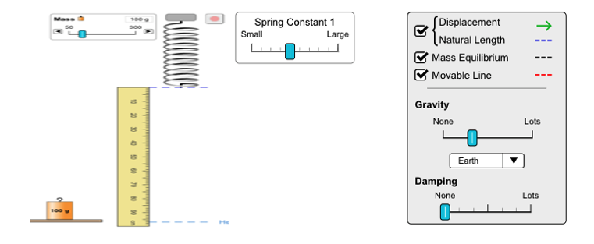
Images are not to scale.

Procedure

Develop a procedure and write each step needed for the calculation of the constant.

Step 1 | Set the slider of the Spring Constant somewhere between Small and Large and do not change it.
Step 2
Step 3
Step 4
Step 5
Step 6
Step 7
*You may not need all boxes or you may need more.

Apply the procedure you developed to collect data needed to find the spring constant.

Data Table

Mass  (g) | Mass  (kg) | Weight (F_{g})  (N) | Extension  (cm) | Extension  (m)

Graphing results:

Force (N) as a function of extension (m): Calculation of slope:



Analysis

What is the significance of the slope of the graph you drew?

Prove Hooke’s mathematical relationship as mentioned above using the data collected.

Conclusions

Describe the link between the value of “k” and its stretching ability.

